Name: QUNTECRADIATION.ORG
Bought through
www.namecheap.com
Main page layout perhaps similar to PENTEC, but Brian, I suspect you can do better


Need a cool picture or even better rotating pictures. Here is a few:
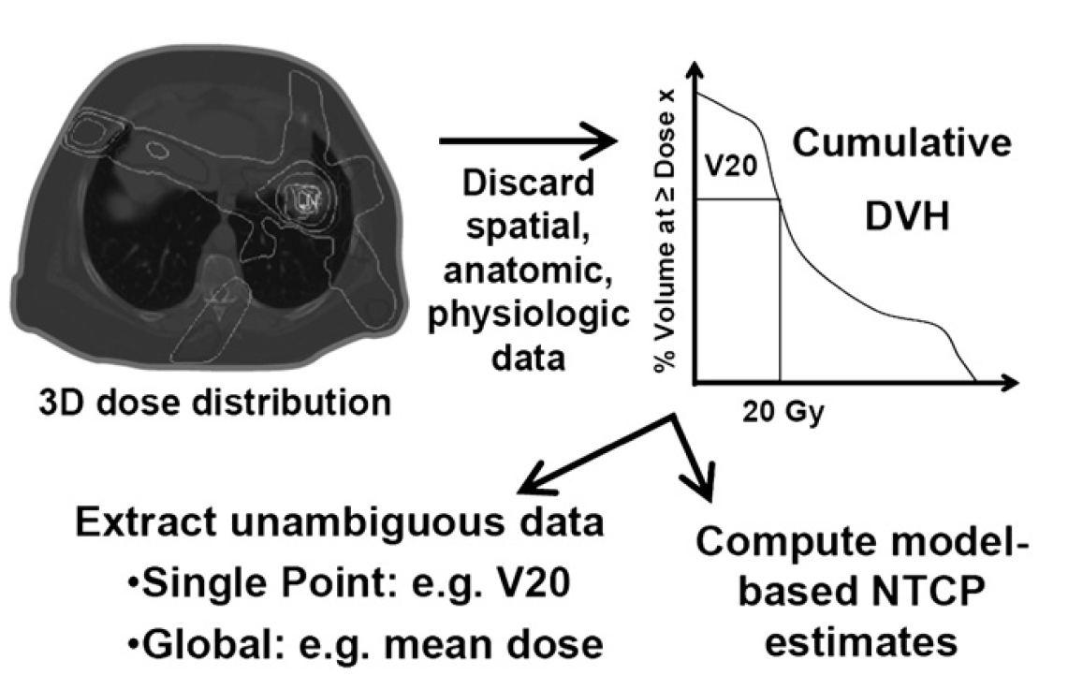
And this (resolution is crap):
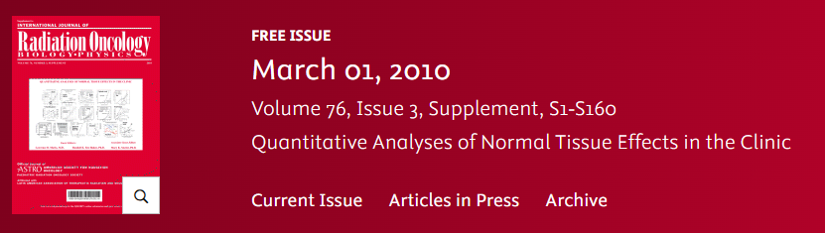

Some visual art to say “In collaboration between AAPM, ASTRO and ESTRO” but I would rather not use the logos as this is for now only an agreement reached at the ASTRO kick-off meeting, nothing formal

Tab 1 after Home: QUANTEC
Pulldown menu
Publication. QUANTEC (Quantitative Analysis of Normal Tissue Effects in the Clinic) reports were published as a special issue of the International Journal of Radiation Oncology Biology Physics (red Journal), 2010, Vol. 76, No. 3, Supplement:
https://www.redjournal.org/issue/S0360-3016(10)X0002-5
This issue included 3 introductory, 16 organ-specific and 5 vision papers.
QUANTEC objective. As described in the introductory QUANTEC paper, “Use of normal tissue probability models in the clinic”, Lawrence B. Marks, Ellen D. Yorke, Andrew Jackson, Randall K. Ten Haken, Louis S. Constine, Avraham Eisbruch, Søren M. Bentzen, Jiho Nam, and Joseph O. Deasy, IJROBP, 2010, Vol. 76, No. 3, Supplement, pp. S10-S19: “The Quantitative Analysis of Normal Tissue Effects in the Clinic (QUANTEC) review summarizes the currently available three-dimensional dose/volume/outcome data to update and refine the normal tissue dose/volume tolerance guidelines provided by the classic Emami et al. paper published in 1991. A ‘‘clinician’s view’’ on using the QUANTEC information in a responsible manner is presented along with a description of the most commonly used normal tissue complication probability (NTCP) models. A summary of organ-specific dose/volume/outcome data, based on the QUANTEC reviews, is included.
Introductory QIANTEC papers.
- Guest Editor’s Introduction to QUANTEC: A User Guide, by Lawrence B. Marks, Randall K. Ten Haken and May K. Martel https://www.redjournal.org/article/S0360-3016(09)03302-1/fulltext
- Quantitative Analyses of Normal Tissue Effects in the Clinic (QUANTEC): An Introduction to the Scientific Issue, by Søren M. Bentzen, Louis S. Constine, Joseph O. Deasy, Avi Eisbruch, Andrew Jackson, Lawrence B. Marks, Randall K. Ten Haken, and Ellen D. Yorke https://www.redjournal.org/article/S0360-3016(09)03300-8/fulltext
- Use of normal tissue probability models in the clinic, by Lawrence B. Marks, Ellen D. Yorke, Andrew Jackson, Randall K. Ten Haken, Louis S. Constine, Avraham Eisbruch, Søren M. Bentzen, Jiho Nam, and Joseph O. Deasy https://www.redjournal.org/article/S0360-3016(09)03288-X/fulltext
Organs covered in the original QUANTEC.
- CNS: Brain https://www.redjournal.org/article/S0360-3016(09)03287-8/fulltext
- CNS: Optic Nerve/Chiasm https://www.redjournal.org/article/S0360-3016(09)03284-2/fulltext
- CNS: Brain Stem https://www.redjournal.org/article/S0360-3016(09)03582-2/fulltext
- CNS: Spinal Cord https://www.redjournal.org/article/S0360-3016(09)03296-9/fulltext
- CNS: Ear https://www.redjournal.org/article/S0360-3016(09)03298-2/fulltext
- Head and Neck: Parotid https://www.redjournal.org/article/S0360-3016(09)03289-1/fulltext
- Head and Neck: Larynx/Pharynx https://www.redjournal.org/article/S0360-3016(09)03292-1/fulltext
- Thorax: Lung https://www.redjournal.org/article/S0360-3016(09)03293-3/fulltext
- Thorax: Heart https://www.redjournal.org/article/S0360-3016(09)03290-8/fulltext
- Thorax: Esophagus https://www.redjournal.org/article/S0360-3016(09)03283-0/fulltext
- Abdomen: Liver https://www.redjournal.org/article/S0360-3016(09)03295-7/fulltext
- Abdomen: Stomach/Small Bowel https://www.redjournal.org/article/S0360-3016(09)03286-6/fulltext
- Abdomen: Kidney https://www.redjournal.org/article/S0360-3016(09)03282-9/fulltext
- Pelvis: Bladder https://www.redjournal.org/article/S0360-3016(09)03285-4/fulltext
- Pelvis: Rectum https://www.redjournal.org/article/S0360-3016(09)03291-X/fulltext
- Pelvis: Penile Bulb https://www.redjournal.org/article/S0360-3016(09)03291-X/fulltext
QUANTEC Summary Table. Links:
https://www.redjournal.org/article/S0360-3016(09)03288-X/fulltext
https://en.wikibooks.org/wiki/Radiation_Oncology/Toxicity/QUANTEC
Interviews with Lawrence Marks and Søren Bentzen
Q1. What do you regard as the biggest success of the QUANTEC effort?
Q2. Anything you wish was included in the QUANTEC but was not?
Q3. QUANTEC has led to HyTEC, PENTEC, now re-irradiation effort and QUANTEC 2 are in progress. Did you see this happening when you had a QUANTEC kick-off workshop in Madison, Wisconsin in October of 2007?
Q4. We now know much more about tumor and normal tissue response. However, a common view is improvements in outcomes are a result of better imaging, including multi-modality, which allow to more accurately delineate target volumes and organs at risk, and better targeting, due to rapid acceptance of IGRT. What do you see as a potential next big step to more than incrementally improve cancer care outcomes?
Q5. Lists of authors between QUANTEC, HyTEC and PENTEC show lots of commonalities. What attracts and motivates oncologists, physicists and biostatisticians to participate in these efforts?
Q6. As I understand, QUANTEC 2 will attract new, younger oncologists, physicists and biostatisticians. What advice would you like to give them to make QUANTEC 2 a success?
Q7. Anything else you may want to share?
Tab 2 after Home: QUANTEC 2
Rationale QUANTEC update.
- Most of the data considered in the original QUANTEC reports came from the 3DCRT era. IMRT/VMAT technologies lead to DVHs distinctly different from 3DCRT. Consequently, toxicity data following IMRT/VMAT may, or may not, support recommendations made based on 3DCRT technology.
- For certain sites regional sensitivity or detailed substructure analyses have been performed, e.g., white matter tracts rather than treating brain as a single organ at risk. Recommendations including targeted sparing of organ-subvolumes at risk may further inform treatment planning.
- Use of systemic therapy, in particular immunotherapy, has expanded since publication of the original QUANTEC reports. Systemic therapy serves as a mediator of the radiation response and this modulation needs to be addressed.
- Machine learning in addition to traditional normal tissue complication probability models has become a common method to search for predictors of toxicity. Summary of these reports and their potential clinical use should be addressed in the QUANTEC update.

Sites/toxicities planned for an update.
Brain
Brainstem
Cochlea/hearing loss
Larynx/Pharynx
Optic Nerves/Chiasm
Parotid/Xerostomia
Lung
Heart
Esophagus
Liver
Stomach, Small Bowel
Kidney
Rectum
Bladder
Penile Bulb
New sites/toxicities.
Mandible/necrosis
Bone marrow/hematologic toxicity
Long bone/fracture
Breast/fibrosis
Thyroid/hypothyroidism
Brachial plexus/plexopathy
Kick-off meeting.
Kick-off meeting took place during the ASTRO annual meeting, September 30th, 2025, and included representation from AAPM, ASTRO and ESTRO
Timeline.
QUANTEC 2 is planned to be completed before radiotherapy becomes obsolete

